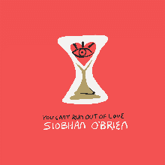

YOU CAN’T RUN OUT OF LOVE – LAUNCHING NOV 2019

Limerick native Siobhán O'Brien relocated to the DC metro area in May 2017. Within 5 weeks she had secured an opening slot (for Nick Lowe) at the famed Birchmere Music Hall and had been selected as a North East Regional Folk Alliance (NERFA) Folk-DJ Showcase Artist by DC radio icon Mary Cliff. Other career highlights for Siobhán include being invited on stage by Bob Dylan (after an impromptu street audition earlier that day), and performing as a guest vocalist for the Chieftains at Boston Symphony Hall. Siobhán’s solo work incorporates traditions of American song including folk, blues, rock, country and some Irish traditional music. Siobhán is a fourth generation musician and is the niece of Brendan Bowyer (The Royal Show Band) as well as the great granddaughter of Albert Bowyer and Olive Westwood of the Bowyer/Westwood Opera Company of Blackpool, England.
Siobhán’s new album was recorded in Austin with producers
John Bush and Matt Hubbard (Edie Brickell & The New Bohemians).

“You Can’t Run Out Of Love” is scheduled to be released in October 2019.

SUGGESTED TRACKS
Track 2 – The King’s Fool – (about being true to yourself)
Track 6 – Hold Me In Your Arms ( about an couple reflecting on their life together and saying “We made a difference”)

For additional information and Tour schedule see Siobhán’s web site
www.siobhanobrien.com

